**MANOVA**

Nadia Ahmad

March, 17 2023

**Assignment Project :**

Multivariate Analysis of Variance (MANOVA) on Travel Discrimination Study relates to gender, race, religion, and travel experience rates

**Data**

The data is obtained through an online survey. Participants will be asked how frequently they traveled, whether they have ever felt discriminated against while traveling, their traveling experience rate, religion, US citizenship, and so on. However, for MANOVA part, only gender, race, religion, travel frequency, and travel experience rate will be used.

**Variable**

The original dataset contains 229 rows and 89 columns. After conducting data cleaning and preprocessing, we reduced our variable into 6 variables.

1. Dependent variable or label

* check in experience rate (checkin_exp).
* travel experience rate (flight_exp).

1. Independent variables

* Factors : gender, race, and religion
* Covariates : travel frequency

**Data Cleaning and Preprocessing**

As we mentioned above, originally, the dataset contains 229 rows and 89 columns. We can’t include all variables as some of them were multiple selections. Therefore, we conducted some preprocessing and data cleaning procedures, listed as follow:

1. Imputing all incomplete responses. Instead of taking out all incomplete progress in surveys, we impute the missing answers with the mode for each variable. Thus, we won’t lose much information.
2. Drop all unused columns. In this step, we keep only 6 variables, which are Q1, Q6_15,, Q6_18, Q15, Q17, and Q18. After that, we rename the ramained columns as we listed at the variable part.
3. Last, we convert the dependent variables of checkin_exp and flight_exp to numeric. And, the factors predictors into factors.

**Data Analysis**

The analysis will be carried out in R.

**MANOVA**

1. **INTERACTION PLOT**

Since we have three candidates for the factor variable, we will draw the interaction plot for each combination factor with each dependent variable. These combinations are gender vs race, race vs religion, and gender vs religion.

1. **Dependent Variable : Check In Experience Rate**

**Gender vs Race**

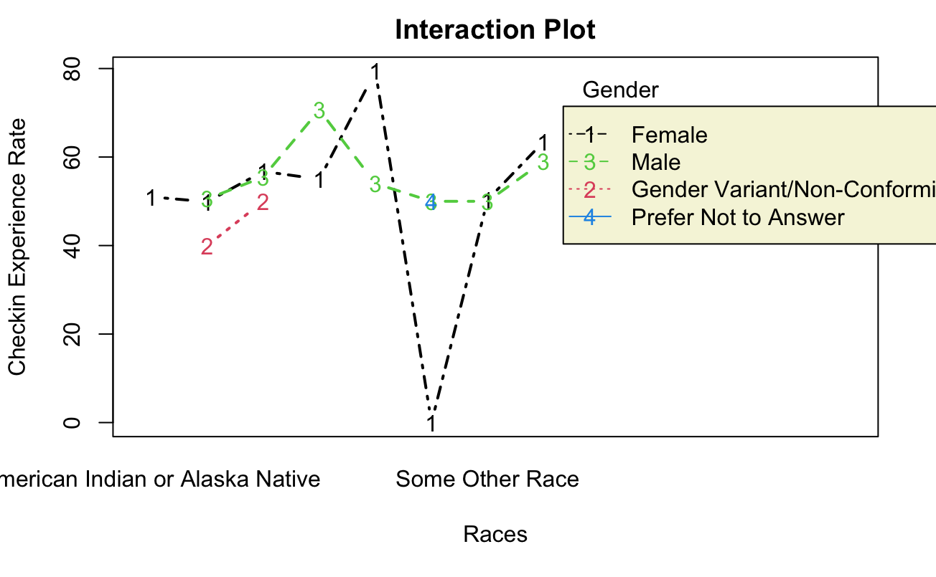

**Gender vs Religion**

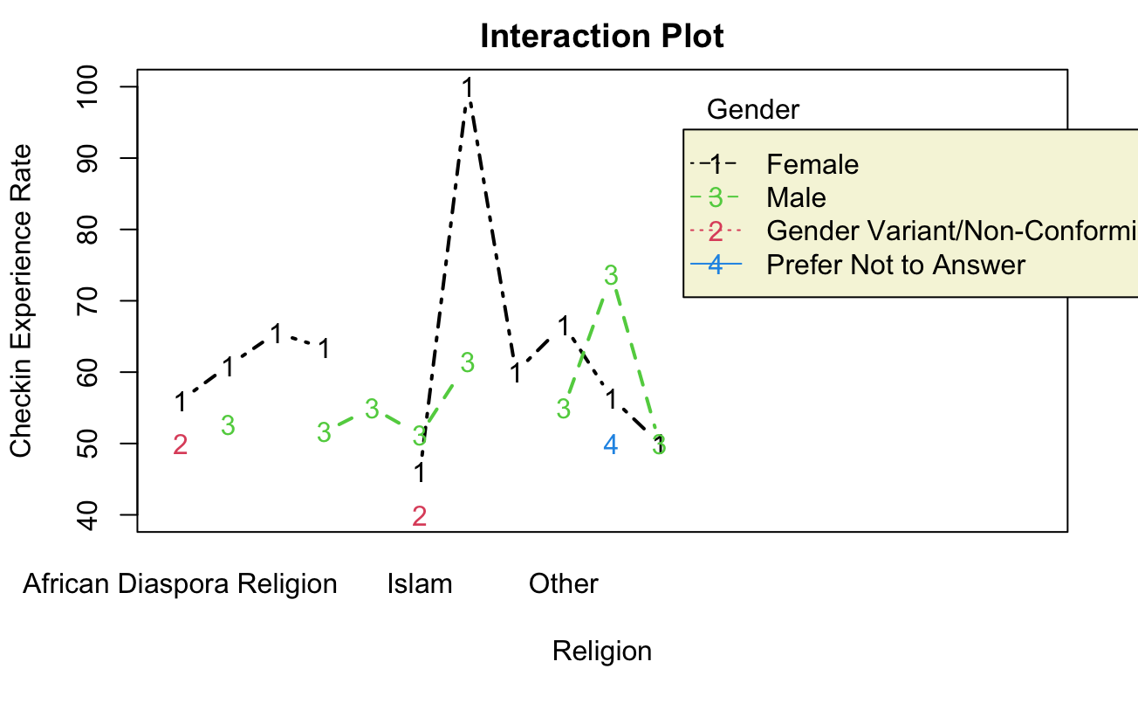

**Race vs Religion**

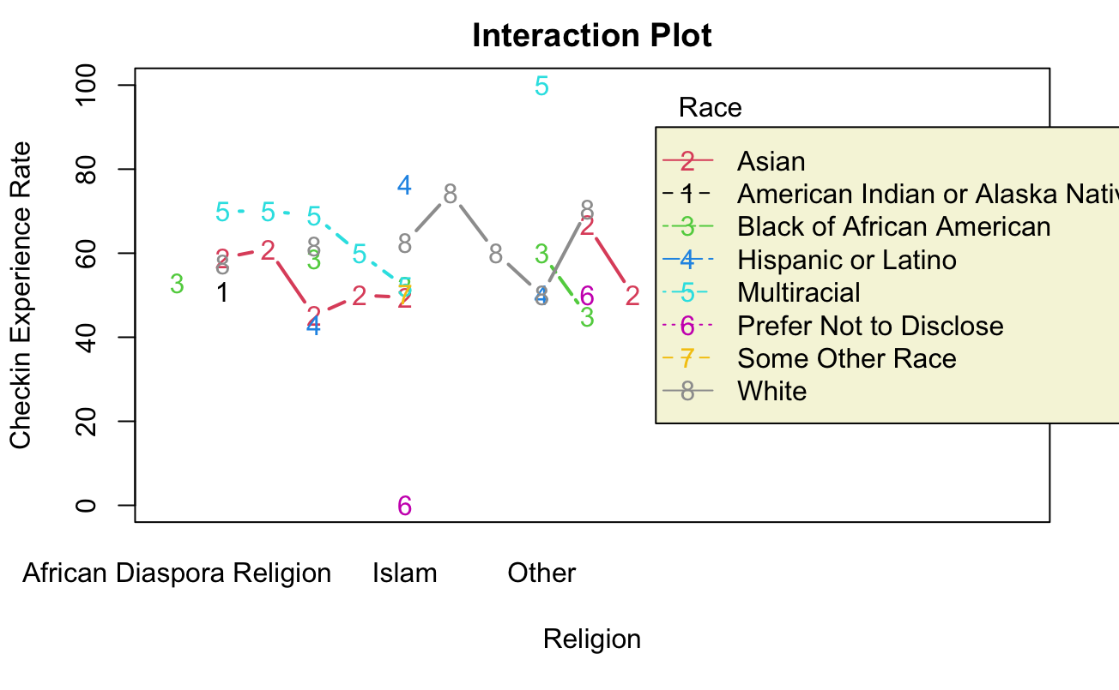

These plots suggest that there might be an interaction between factors variables, which are race and gender, gender and religion, and also religion and race. Also seems like overall that the female check in experience rates is generally higher than the other gender.

1. **Dependent Variable : Travel Experience Rate**

**Gender vs Race**

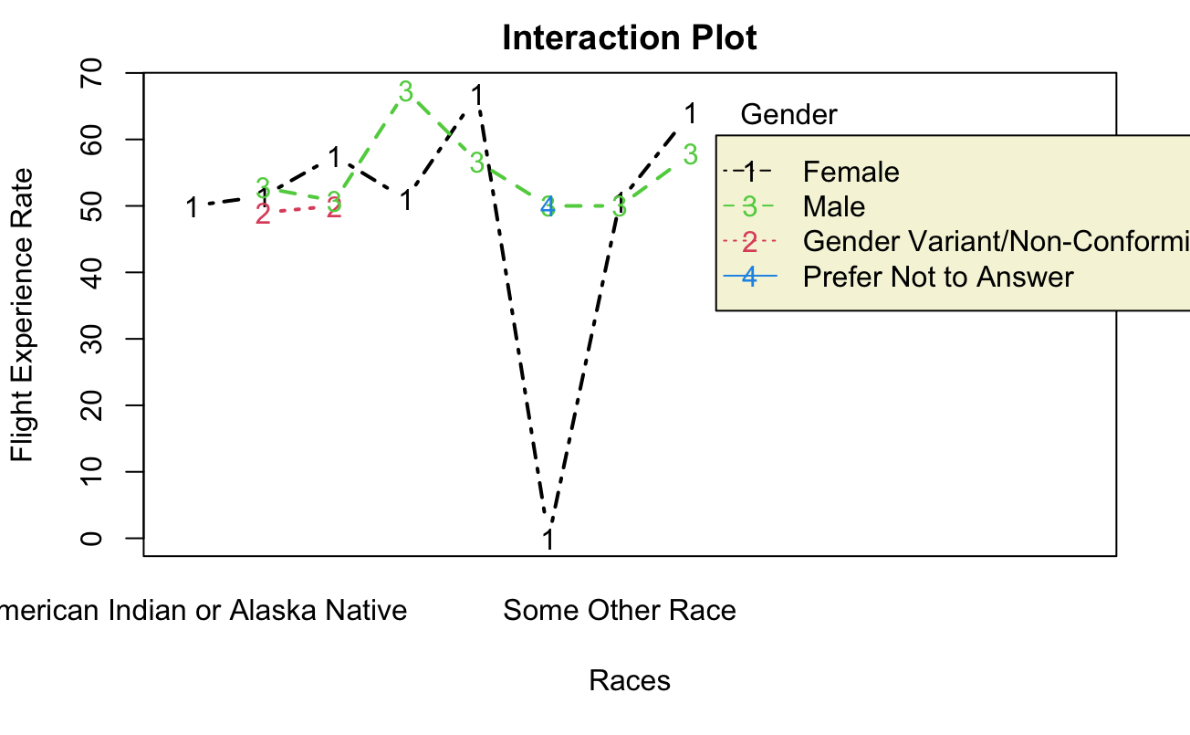

**Gender vs Religion**

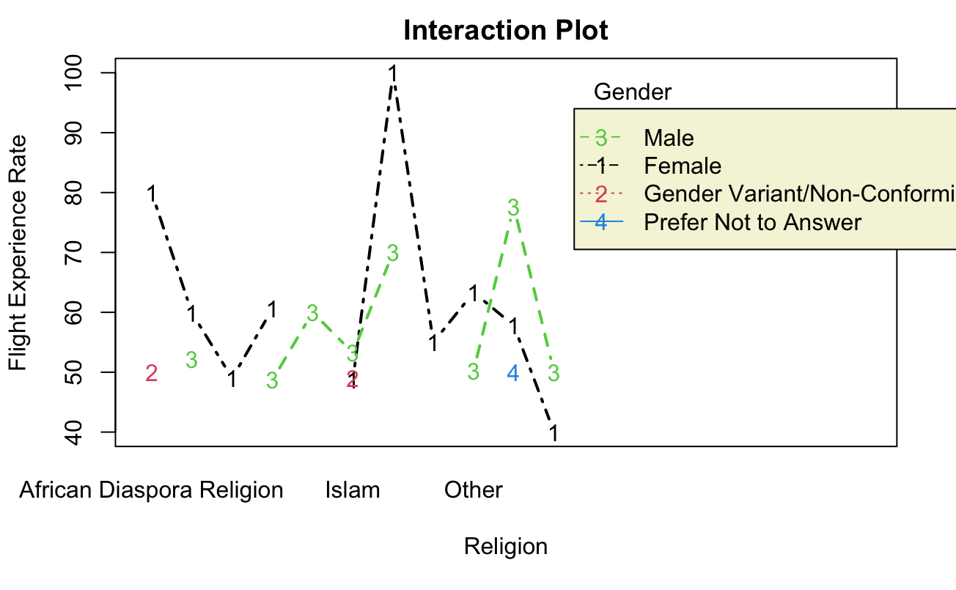

**Race vs Religion**

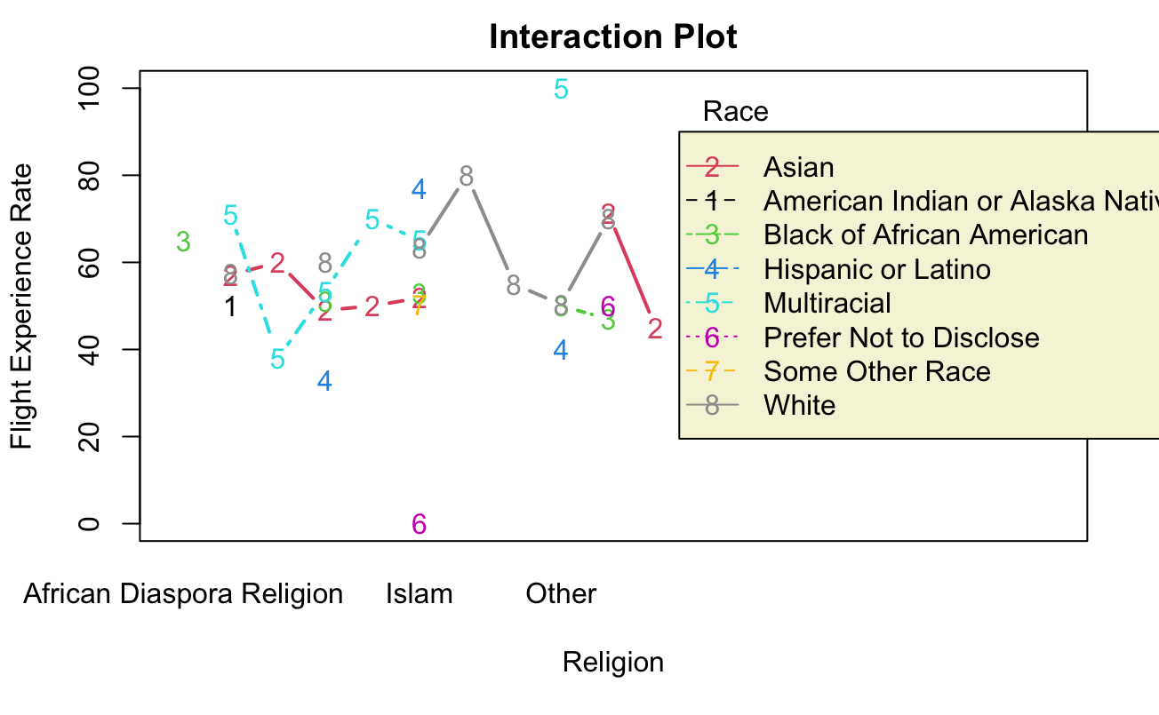

These plots suggest that there might be an interaction between factors variables, which are race and gender, gender and religion, and also religion and race. Also seems like overall that the female flight experience rate is generally higher than the other gender.

1. **TWO WAY MANOVA**

**ANOVA**

**ANOVA 1 : Religion and Gender**

Dependent : Check In Experience Rate

Df Sum Sq Mean Sq F value Pr(>F)

gender 3 706 235.3 0.844 0.4712

religion 10 4799 479.9 1.721 0.0777 .

gender:religion 7 3658 522.5 1.874 0.0752 .

Residuals 208 57983 278.8

---

Signif. codes: 0 ‘***’ 0.001 ‘**’ 0.01 ‘*’ 0.05 ‘.’ 0.1 ‘ ’ 1

Dependent : Flight Experience Rate

Df Sum Sq Mean Sq F value Pr(>F)

gender 3 238 79.3 0.339 0.7972

religion 10 4296 429.6 1.837 0.0560 .

gender:religion 7 3626 518.1 2.215 0.0343 *

Residuals 208 48638 233.8

---

Signif. codes: 0 ‘***’ 0.001 ‘**’ 0.01 ‘*’ 0.05 ‘.’ 0.1 ‘ ’ 1

Both for check in and flight experience rate, there’s no significant effect of gender nor religion to both of the experience rate. Moreover, there’s also no evidence about interaction between these two factors, gender and religion. In other words, the mean of check in and flight experience rate are the same among all of group gender and religion.

**ANOVA 2 : Gender and Race**

Dependent : Check In Experience Rate

Df Sum Sq Mean Sq F value Pr(>F)

gender 3 706 235.3 0.890 0.447165

race 7 7724 1103.5 4.174 0.000251 ***

gender:race 7 2930 418.6 1.583 0.141709

Residuals 211 55784 264.4

---

Signif. codes: 0 ‘***’ 0.001 ‘**’ 0.01 ‘*’ 0.05 ‘.’ 0.1 ‘ ’ 1

Dependent : Flight Experience Rate

Df Sum Sq Mean Sq F value Pr(>F)

gender 3 238 79.3 0.337 0.79859

race 7 4694 670.6 2.852 0.00731 **

gender:race 7 2244 320.6 1.363 0.22235

Residuals 211 49622 235.2

---

Signif. codes: 0 ‘***’ 0.001 ‘**’ 0.01 ‘*’ 0.05 ‘.’ 0.1 ‘ ’ 1

For both dependent variables, there’s no significant effect of gender on the experience rate. In contrast, we can see that different races significantly affect both checkin and flight experience rate. However, there's no evidence about interaction between these two factors.

**ANOVA 3 : Race and Religion**

Dependent : Check In Experience Rate

Df Sum Sq Mean Sq F value Pr(>F)

religion 10 5242 524.2 1.994 0.03572 *

race 7 5177 739.6 2.814 0.00816 **

religion:race 14 4945 353.2 1.344 0.18461

Residuals 197 51781 262.8

---

Signif. codes: 0 ‘***’ 0.001 ‘**’ 0.01 ‘*’ 0.05 ‘.’ 0.1 ‘ ’ 1

Dependent : Flight Experience Rate

Df Sum Sq Mean Sq F value Pr(>F)

religion 10 4102 410.2 1.911 0.04556 *

race 7 4527 646.7 3.013 0.00498 **

religion:race 14 5888 420.5 1.959 0.02267 *

Residuals 197 42282 214.6

---

Signif. codes: 0 ‘***’ 0.001 ‘**’ 0.01 ‘*’ 0.05 ‘.’ 0.1 ‘ ’ 1

For check in experience rate, both factors, religion and race significantly affect the rate. It means, the mean of check in rate significantly differs among the religion and race group. However, there’s no evidence that shows the interaction between these two factors. Next, for flight experience rate, both factors, religion and race significantly affect the rate. Moreover, there’s also significant interactions between these two factors.

**MANOVA**

**MANOVA 1**

Dependent : Check in experience rate, flight experience rate

Factors : Gender and Race

Df Pillai approx F num Df den Df Pr(>F)

gender 3 0.012843 0.45455 6 422 0.841726

race 7 0.143232 2.32523 14 422 0.004276 **

gender:race 7 0.067957 1.06023 14 422 0.392356

Residuals 211

---

Signif. codes: 0 ‘***’ 0.001 ‘**’ 0.01 ‘*’ 0.05 ‘.’ 0.1 ‘ ’ 1

Response checkin_exp :

Df Sum Sq Mean Sq F value Pr(>F)

gender 3 706 235.29 0.8900 0.447165

race 7 7724 1103.46 4.1737 0.000251 ***

gender:race 7 2930 418.63 1.5835 0.141709

Residuals 211 55784 264.38

---

Signif. codes: 0 ‘***’ 0.001 ‘**’ 0.01 ‘*’ 0.05 ‘.’ 0.1 ‘ ’ 1

Response fly_exp :

Df Sum Sq Mean Sq F value Pr(>F)

gender 3 238 79.26 0.3370 0.798590

race 7 4694 670.63 2.8516 0.007308 **

gender:race 7 2244 320.62 1.3633 0.222354

Residuals 211 49622 235.17

---

Signif. codes: 0 ‘***’ 0.001 ‘**’ 0.01 ‘*’ 0.05 ‘.’ 0.1 ‘ ’ 1

For the first MANOVA model, we use gender and religion as factors. From the output, only race factors that significantly affect the difference of combination of dependent variables.

**MANOVA 2**

Dependent : Check in experience rate, flight experience rate

Factors : Gender and Religion

Df Pillai approx F num Df den Df Pr(>F)

gender 3 0.012388 0.43212 6 416 0.8575

religion 10 0.126620 1.40585 20 416 0.1145

gender:religion 7 0.089753 1.39613 14 416 0.1511

Residuals 208

Response checkin_exp :

Df Sum Sq Mean Sq F value Pr(>F)

gender 3 706 235.29 0.8441 0.47116

religion 10 4799 479.87 1.7214 0.07767 .

gender:religion 7 3658 522.53 1.8745 0.07520 .

Residuals 208 57983 278.76

---

Signif. codes: 0 ‘***’ 0.001 ‘**’ 0.01 ‘*’ 0.05 ‘.’ 0.1 ‘ ’ 1

Response fly_exp :

Df Sum Sq Mean Sq F value Pr(>F)

gender 3 238 79.26 0.3389 0.79719

religion 10 4296 429.60 1.8372 0.05599 .

gender:religion 7 3626 518.06 2.2155 0.03430 *

Residuals 208 48638 233.84

---

Signif. codes: 0 ‘***’ 0.001 ‘**’ 0.01 ‘*’ 0.05 ‘.’ 0.1 ‘ ’ 1

The second MANOVA model shows the insignificant factors of gender and religion. It means, there’s no different of combined dependent variables among the gender and religion group.

**MANOVA 3**

Dependent : Check in experience rate, flight experience rate

Factors : Race and Religion

Df Pillai approx F num Df den Df Pr(>F)

race 7 0.15825 2.4181 14 394 0.002913 **

religion 10 0.11246 1.1738 20 394 0.273406

race:religion 14 0.15838 1.2101 28 394 0.215616

Residuals 197

---

Signif. codes: 0 ‘***’ 0.001 ‘**’ 0.01 ‘*’ 0.05 ‘.’ 0.1 ‘ ’ 1

Response checkin_exp :

Df Sum Sq Mean Sq F value Pr(>F)

race 7 7866 1123.65 4.2749 0.0002017 ***

religion 10 2554 255.35 0.9715 0.4695651

race:religion 14 4945 353.22 1.3438 0.1846120

Residuals 197 51781 262.85

---

Signif. codes: 0 ‘***’ 0.001 ‘**’ 0.01 ‘*’ 0.05 ‘.’ 0.1 ‘ ’ 1

Response fly_exp :

Df Sum Sq Mean Sq F value Pr(>F)

race 7 4488 641.10 2.9870 0.005313 **

religion 10 4141 414.12 1.9295 0.043194 *

race:religion 14 5888 420.54 1.9594 0.022670 *

Residuals 197 42282 214.63

---

Signif. codes: 0 ‘***’ 0.001 ‘**’ 0.01 ‘*’ 0.05 ‘.’ 0.1 ‘ ’ 1

Same as the first MANOVA model, MANOVA 3 tells us that the combination of dependent variables statistically has significant differences between the race groups. But, we can’t see any evidence that supports interaction between race and religion on MANOVA.

Based on ANOVA and MANOVA results, we decided to use race and religion as factors for further analysis.

**Test Assumption for MANOVA3**

Pillai’s Trace

Df Pillai approx F num Df den Df Pr(>F)

race 7 0.15825 2.4181 14 394 0.002913 **

religion 10 0.11246 1.1738 20 394 0.273406

race:religion 14 0.15838 1.2101 28 394 0.215616

Residuals 197

---

Signif. codes: 0 ‘***’ 0.001 ‘**’ 0.01 ‘*’ 0.05 ‘.’ 0.1 ‘ ’ 1

Wilk’s Lambda

Df Wilks approx F num Df den Df Pr(>F)

race 7 0.84308 2.4947 14 392 0.002088 **

religion 10 0.88951 1.1816 20 392 0.266324

race:religion 14 0.84493 1.2306 28 392 0.197405

Residuals 197

---

Signif. codes: 0 ‘***’ 0.001 ‘**’ 0.01 ‘*’ 0.05 ‘.’ 0.1 ‘ ’ 1

Hotelling’s Trace

Df Hotelling-Lawley approx F num Df den Df Pr(>F)

race 7 0.18456 2.5707 14 390 0.001496 **

religion 10 0.12199 1.1894 20 390 0.259486

race:religion 14 0.17960 1.2508 28 390 0.180543

Residuals 197

---

Signif. codes: 0 ‘***’ 0.001 ‘**’ 0.01 ‘*’ 0.05 ‘.’ 0.1 ‘ ’ 1

Roy’s Largest Root

Df Roy approx F num Df den Df Pr(>F)

race 7 0.175617 4.9424 7 197 3.618e-05 ***

religion 10 0.099669 1.9635 10 197 0.03911 *

race:religion 14 0.154187 2.1696 14 197 0.01015 *

Residuals 197

---

Signif. codes: 0 ‘***’ 0.001 ‘**’ 0.01 ‘*’ 0.05 ‘.’ 0.1 ‘ ’ 1

1. **MULTIVARIATE CONTRASTS**
2. **Univariate Level**

**Factor : Race**

Multivariate Pairwise Comparisons

Pillai approx F num DF

American Indian or Alaska Native - Asian 0.000217 0.0228

American Indian or Alaska Native - Black of African American 0.000377 0.0396

American Indian or Alaska Native - Hispanic or Latino 0.003111 0.3277

American Indian or Alaska Native - Multiracial 0.005985 0.6322 American Indian or Alaska Native - Prefer Not to Disclose 0.005584 0.5896

American Indian or Alaska Native - Some Other Race 0.000023 0.0024

American Indian or Alaska Native - White 0.002961 0.3118

Asian - Black of African American 0.004251 0.4482

Asian - Hispanic or Latino 0.017110 1.8278

Asian - Multiracial 0.049315 5.4467

Asian - Prefer Not to Disclose 0.024622 2.6506

Asian - Some Other Race 0.000663 0.0696

Asian - White 0.068436 7.7137

Black of African American - Hispanic or Latino 0.005302 0.5597

Black of African American - Multiracial 0.016090 1.7170

Black of African American - Prefer Not to Disclose 0.025063 2.6993

Black of African American - Some Other Race 0.001841 0.1937

Black of African American - White 0.009006 0.9542

Hispanic or Latino - Multiracial 0.001634 0.1718

Hispanic or Latino - Prefer Not to Disclose 0.039136 4.2767

Hispanic or Latino - Some Other Race 0.010743 1.1402

Hispanic or Latino - White 0.001062 0.1116

Multiracial - Prefer Not to Disclose 0.057569 6.4139

Multiracial - Some Other Race 0.024045 2.5870

Multiracial - White 0.008894 0.9422

Prefer Not to Disclose - Some Other Race 0.014456 1.5402 Prefer Not to Disclose - White 0.052484 5.8161

Some Other Race - White 0.015793 1.6849

den DF Pr(>F)

American Indian or Alaska Native - Asian 210 0.9774660

American Indian or Alaska Native - Black of African American 210 0.9611607

American Indian or Alaska Native - Hispanic or Latino 210 0.7209785

American Indian or Alaska Native - Multiracial 210 0.5324069

American Indian or Alaska Native - Prefer Not to Disclose 210 0.5554651

American Indian or Alaska Native - Some Other Race 210 0.9975944

American Indian or Alaska Native - White 210 0.7324412

Asian - Black of African American 210 0.6393624

Asian - Hispanic or Latino 210 0.1633143

Asian - Multiracial 210 0.0049415 **

Asian - Prefer Not to Disclose 210 0.0729733 .

Asian - Some Other Race 210 0.9327803

Asian - White 210 0.0005852 ***

Black of African American - Hispanic or Latino 210 0.5722235

Black of African American - Multiracial 210 0.1821075

Black of African American - Prefer Not to Disclose 210 0.0695854 .

Black of African American - Some Other Race 210 0.8240694

Black of African American - White 210 0.3867768

Hispanic or Latino - Multiracial 210 0.8422401

Hispanic or Latino - Prefer Not to Disclose 210 0.0151182 *

Hispanic or Latino - Some Other Race 210 0.3217224

Hispanic or Latino - White 210 0.8944385

Multiracial - Prefer Not to Disclose 210 0.0019780 **

Multiracial - Some Other Race 210 0.0776436 .

Multiracial - White 210 0.3913989

Prefer Not to Disclose - Some Other Race 210 0.2167540

Prefer Not to Disclose - White 210 0.0034799 **

Some Other Race - White 210 0.1879651

---

Signif. codes: 0 ‘***’ 0.001 ‘**’ 0.01 ‘*’ 0.05 ‘.’ 0.1 ‘ ’ 1

With none p-value adjustment for multiple comparisons

From ANOVA setting, we calculate the pairwise comparison contrasts between race factors to see which group factors are different from each other. In our case, Asian - Multiracial, Asian - White, Hispanic or Latino - Multiracial, Hispanic - Latino, Multiracial - prefer not to disclose, and prefer not disclose - white have significant different contrasts.

**Factor : Religion**

Analysis of Variance Table

Df Pillai approx F num Df den Df Pr(>F)

(Intercept) 1 0.94396 1768.60 2 210 < 2.2e-16 ***

race 7 0.14232 2.31 14 422 0.004579 **

religion 10 0.10105 1.12 20 422 0.322227

Residuals 211

---

Signif. codes: 0 ‘***’ 0.001 ‘**’ 0.01 ‘*’ 0.05 ‘.’ 0.1 ‘ ’ 1

Multivariate Pairwise Comparisons

Pillai approx F num DF

African Diaspora Religion - Atheism/Agnosticism 0.005803 0.6128 2

African Diaspora Religion - Buddhism 0.015783 1.6838 2

African Diaspora Religion - Christianity 0.008506 0.9008 2

African Diaspora Religion - Hinduism 0.001051 0.1104 2

African Diaspora Religion - Islam 0.007313 0.7735 2

African Diaspora Religion - Judaism 0.010376 1.1009 2

African Diaspora Religion - Judaism,Atheism/Agnosticism 0.003831 0.4038 2

African Diaspora Religion - Other 0.007954 0.8419 2

African Diaspora Religion - Prefer Not to Disclose 0.003366 0.3546 2

African Diaspora Religion - Sikhism 0.009714 1.0300 2

Atheism/Agnosticism - Buddhism 0.008577 0.9084 2

Atheism/Agnosticism - Christianity 0.001644 0.1729 2

Atheism/Agnosticism - Hinduism 0.001165 0.1225 2

Atheism/Agnosticism - Islam 0.019443 2.0820 2

Atheism/Agnosticism - Judaism 0.026511 2.8595 2

Atheism/Agnosticism - Judaism,Atheism/Agnosticism 0.000336 0.0353 2

Atheism/Agnosticism - Other 0.001069 0.1124 2

Atheism/Agnosticism - Prefer Not to Disclose 0.004257 0.4489 2

Atheism/Agnosticism - Sikhism 0.006005 0.6344 2

Buddhism - Christianity 0.006638 0.7017 2

Buddhism - Hinduism 0.008906 0.9436 2

Buddhism - Islam 0.014118 1.5036 2

Buddhism - Judaism 0.025188 2.7131 2

Buddhism - Judaism,Atheism/Agnosticism 0.001716 0.1804 2

Buddhism - Other 0.004657 0.4912 2

Buddhism - Prefer Not to Disclose 0.012653 1.3456 2

Buddhism - Sikhism 0.004504 0.4751 2

Christianity - Hinduism 0.002338 0.2461 2

Christianity - Islam 0.025530 2.7509 2

Christianity - Judaism 0.034223 3.7207 2

Christianity - Judaism,Atheism/Agnosticism 0.000102 0.0107 2

Christianity - Other 0.000428 0.0450 2

Christianity - Prefer Not to Disclose 0.010280 1.0906 2

Christianity - Sikhism 0.004169 0.4395 2

Hinduism - Islam 0.002438 0.2566 2

Hinduism - Judaism 0.011810 1.2549 2

Hinduism - Judaism,Atheism/Agnosticism 0.001291 0.1357 2

Hinduism - Other 0.002496 0.2628 2

Hinduism - Prefer Not to Disclose 0.001211 0.1273 2

Hinduism - Sikhism 0.004894 0.5164 2

Islam - Judaism 0.049921 5.5172 2

Islam - Judaism,Atheism/Agnosticism 0.001818 0.1912 2

Islam - Other 0.011661 1.2388 2

Islam - Prefer Not to Disclose 0.026984 2.9119 2

Islam - Sikhism 0.002902 0.3056 2

Judaism - Judaism,Atheism/Agnosticism 0.009644 1.0225 2

Judaism - Other 0.024838 2.6744 2

Judaism - Prefer Not to Disclose 0.013250 1.4100 2

Judaism - Sikhism 0.030318 3.2829 2

Judaism,Atheism/Agnosticism - Other 0.000018 0.0019 2

Judaism,Atheism/Agnosticism - Prefer Not to Disclose 0.001590 0.1672 2

Judaism,Atheism/Agnosticism - Sikhism 0.001703 0.1791 2

Other - Prefer Not to Disclose 0.005534 0.5843 2

Other - Sikhism 0.004390 0.4629 2

Prefer Not to Disclose - Sikhism 0.011622 1.2346 2

den DF Pr(>F)

African Diaspora Religion - Atheism/Agnosticism 210 0.542774

African Diaspora Religion - Buddhism 210 0.188168

African Diaspora Religion - Christianity 210 0.407824

African Diaspora Religion - Hinduism 210 0.895498

African Diaspora Religion - Islam 210 0.462711

African Diaspora Religion - Judaism 210 0.334476

African Diaspora Religion - Judaism,Atheism/Agnosticism 210 0.668325

African Diaspora Religion - Other 210 0.432343

African Diaspora Religion - Prefer Not to Disclose 210 0.701878

African Diaspora Religion - Sikhism 210 0.358819

Atheism/Agnosticism - Buddhism 210 0.404743

Atheism/Agnosticism - Christianity 210 0.841329

Atheism/Agnosticism - Hinduism 210 0.884794

Atheism/Agnosticism - Islam 210 0.127250

Atheism/Agnosticism - Judaism 210 0.059532 .

Atheism/Agnosticism - Judaism,Atheism/Agnosticism 210 0.965319

Atheism/Agnosticism - Other 210 0.893753

Atheism/Agnosticism - Prefer Not to Disclose 210 0.638970

Atheism/Agnosticism - Sikhism 210 0.531289

Buddhism - Christianity 210 0.496913

Buddhism - Hinduism 210 0.390885

Buddhism - Islam 210 0.224716

Buddhism - Judaism 210 0.068657 .

Buddhism - Judaism,Atheism/Agnosticism 210 0.835031

Buddhism - Other 210 0.612571

Buddhism - Prefer Not to Disclose 210 0.262614

Buddhism - Sikhism 210 0.622502

Christianity - Hinduism 210 0.782080

Christianity - Islam 210 0.066173 .

Christianity - Judaism 210 0.025828 *

Christianity - Judaism,Atheism/Agnosticism 210 0.989352

Christianity - Other 210 0.956003

Christianity - Prefer Not to Disclose 210 0.337911

Christianity - Sikhism 210 0.644925

Hinduism - Islam 210 0.773924

Hinduism - Judaism 210 0.287233

Hinduism - Judaism,Atheism/Agnosticism 210 0.873168

Hinduism - Other 210 0.769160

Hinduism - Prefer Not to Disclose 210 0.880572

Hinduism - Sikhism 210 0.597429

Islam - Judaism 210 0.004621 **

Islam - Judaism,Atheism/Agnosticism 210 0.826098

Islam - Other 210 0.291835

Islam - Prefer Not to Disclose 210 0.056571 .

Islam - Sikhism 210 0.737021

Judaism - Judaism,Atheism/Agnosticism 210 0.361479

Judaism - Other 210 0.071299 .

Judaism - Prefer Not to Disclose 210 0.246453

Judaism - Sikhism 210 0.039454 *

Judaism,Atheism/Agnosticism - Other 210 0.998119

Judaism,Atheism/Agnosticism - Prefer Not to Disclose 210 0.846120

Judaism,Atheism/Agnosticism - Sikhism 210 0.836153

Other - Prefer Not to Disclose 210 0.558407

Other - Sikhism 210 0.630068

Prefer Not to Disclose - Sikhism 210 0.293042

---

Signif. codes: 0 ‘***’ 0.001 ‘**’ 0.01 ‘*’ 0.05 ‘.’ 0.1 ‘ ’ 1

With none p-value adjustment for multiple comparisons

From ANOVA setting, we calculate the pairwise comparison contrasts between religion factors to see which group factors are different from each other. In our case,Christianity - Judaism, Islam - Judaism, and Judaism - Sikhism have significant different contrasts.

1. **Multivariate Level**

**Factor : Race**

$estimates

contrast = Asian - American Indian or Alaska Native:

rep.meas estimate SE df t.ratio p.value

checkin_exp 3.34 17.02 211 0.196 0.8445

fly_exp 4.14 15.68 211 0.264 0.7920

contrast = Black of African American - Asian:

rep.meas estimate SE df t.ratio p.value

checkin_exp 3.37 7.13 211 0.473 0.6369

fly_exp -2.54 6.57 211 -0.387 0.6991

contrast = Hispanic or Latino - Black of African American:

rep.meas estimate SE df t.ratio p.value

checkin_exp 10.89 9.76 211 1.115 0.2660

fly_exp 12.05 9.00 211 1.340 0.1817

contrast = Multiracial - Hispanic or Latino:

rep.meas estimate SE df t.ratio p.value

checkin_exp 4.46 9.69 211 0.460 0.6463

fly_exp 3.23 8.93 211 0.362 0.7177

contrast = Prefer Not to Disclose - Multiracial:

rep.meas estimate SE df t.ratio p.value

checkin_exp -45.43 12.15 211 -3.738 0.0002

fly_exp -42.71 11.20 211 -3.814 0.0002

contrast = Some Other Race - Prefer Not to Disclose:

rep.meas estimate SE df t.ratio p.value

checkin_exp 27.26 12.32 211 2.213 0.0279

fly_exp 28.16 11.35 211 2.481 0.0139

contrast = White - Some Other Race:

rep.meas estimate SE df t.ratio p.value

checkin_exp 7.29 7.94 211 0.919 0.3593

fly_exp 9.09 7.32 211 1.243 0.2154

Results are averaged over the levels of: religion

$tests

contrast T.square df1 df2 F.ratio p.value

Asian - American Indian or Alaska Native 0.075 2 210 0.037 1.0000

Black of African American - Asian 0.750 2 210 0.373 0.9997

Hispanic or Latino - Black of African American 2.053 2 210 1.022 0.9569

Multiracial - Hispanic or Latino 0.234 2 210 0.116 1.0000

Prefer Not to Disclose - Multiracial 18.947 2 210 9.429 0.0008

Some Other Race - Prefer Not to Disclose 7.392 2 210 3.679 0.1738

White - Some Other Race 1.658 2 210 0.825 0.9827

P value adjustment: sidak

At multivariate level, only prefer not disclose - multiracial has significantly different contrast or significant difference on multivariate centroids of the race group.

**Factor : Religion**

$estimates

contrast = (Atheism/Agnosticism) - African Diaspora Religion:

rep.meas estimate SE df t.ratio p.value

checkin_exp 4.71 14.02 211 0.336 0.7373

fly_exp -13.40 12.92 211 -1.037 0.3010

contrast = Buddhism - (Atheism/Agnosticism):

rep.meas estimate SE df t.ratio p.value

checkin_exp 1.80 12.66 211 0.142 0.8870

fly_exp -11.52 11.67 211 -0.987 0.3248

contrast = Christianity - Buddhism:

rep.meas estimate SE df t.ratio p.value

checkin_exp -5.29 12.41 211 -0.426 0.6705

fly_exp 7.11 11.43 211 0.622 0.5347

contrast = Hinduism - Christianity:

rep.meas estimate SE df t.ratio p.value

checkin_exp -5.21 12.41 211 -0.420 0.6747

fly_exp 3.89 11.43 211 0.340 0.7340

contrast = Islam - Hinduism:

rep.meas estimate SE df t.ratio p.value

checkin_exp 3.99 12.12 211 0.329 0.7427

fly_exp -1.49 11.17 211 -0.133 0.8943

contrast = Judaism - Islam:

rep.meas estimate SE df t.ratio p.value

checkin_exp 16.87 10.38 211 1.625 0.1057

fly_exp 20.58 9.57 211 2.150 0.0327

contrast = (Judaism,Atheism/Agnosticism) - Judaism:

rep.meas estimate SE df t.ratio p.value

checkin_exp -14.33 18.93 211 -0.757 0.4499

fly_exp -25.00 17.45 211 -1.433 0.1534

contrast = Other - (Judaism,Atheism/Agnosticism):

rep.meas estimate SE df t.ratio p.value

checkin_exp -1.20 17.77 211 -0.067 0.9463

fly_exp 2.57 16.37 211 0.157 0.8756

contrast = Prefer Not to Disclose - Other:

rep.meas estimate SE df t.ratio p.value

checkin_exp 14.30 8.90 211 1.606 0.1098

fly_exp 18.60 8.20 211 2.267 0.0244

contrast = Sikhism - Prefer Not to Disclose:

rep.meas estimate SE df t.ratio p.value

checkin_exp -15.27 13.13 211 -1.163 0.2460

fly_exp -23.88 12.09 211 -1.974 0.0497

Results are averaged over the levels of: race

$tests

contrast T.square df1 df2 F.ratio p.value

(Atheism/Agnosticism) - African Diaspora Religion 2.069 2 210 1.029 0.9883

Buddhism - (Atheism/Agnosticism) 1.526 2 210 0.760 0.9982

Christianity - Buddhism 1.123 2 210 0.559 0.9998

Hinduism - Christianity 0.587 2 210 0.292 1.0000

Islam - Hinduism 0.228 2 210 0.114 1.0000

Judaism - Islam 5.012 2 210 2.494 0.5888

(Judaism,Atheism/Agnosticism) - Judaism 2.055 2 210 1.022 0.9887

Other - (Judaism,Atheism/Agnosticism) 0.053 2 210 0.027 1.0000

Prefer Not to Disclose - Other 5.422 2 210 2.698 0.5143

Sikhism - Prefer Not to Disclose 3.934 2 210 1.958 0.7881

P value adjustment: sidak

Related to the MANOVA test, there’s no group in religion that has multivariate difference in contrast or centroid difference.

1. **MANCOVA**

Next, instead of only considering factors variables that affect check in and flight experience rate. We want to consider numerical variables, covariates. Here, we take travel frequency into account. Before that, we’ll investigate the relationship via scatter plot.

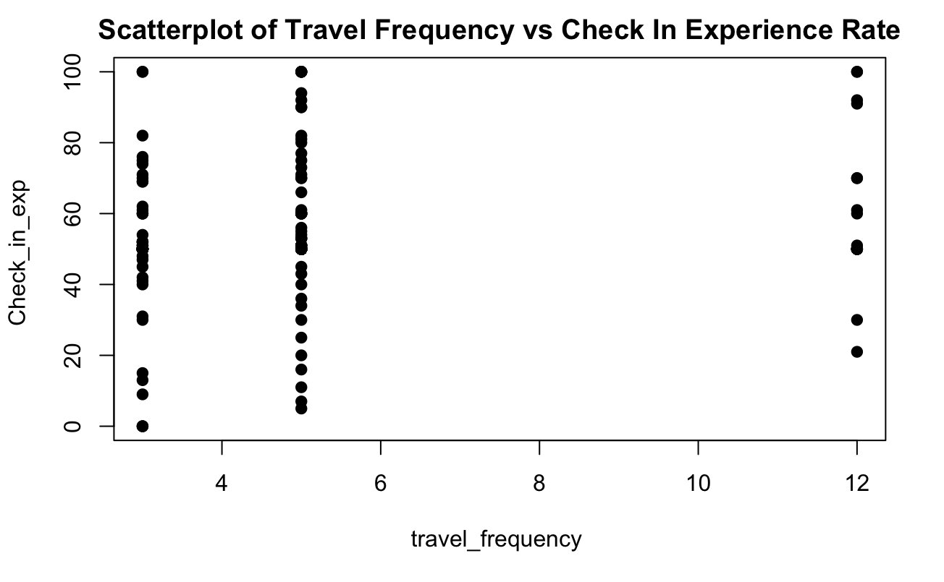

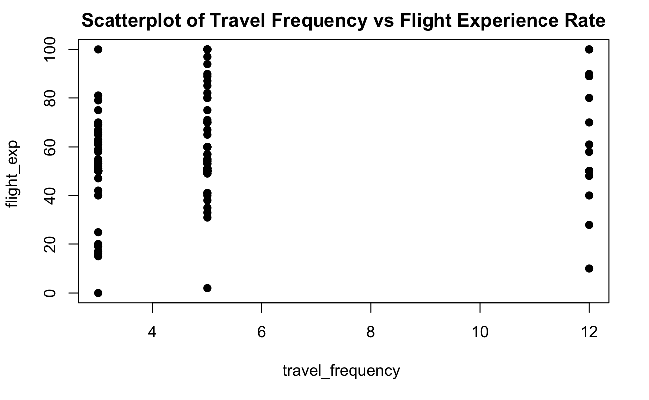

**Univariate (ANCOVA)**

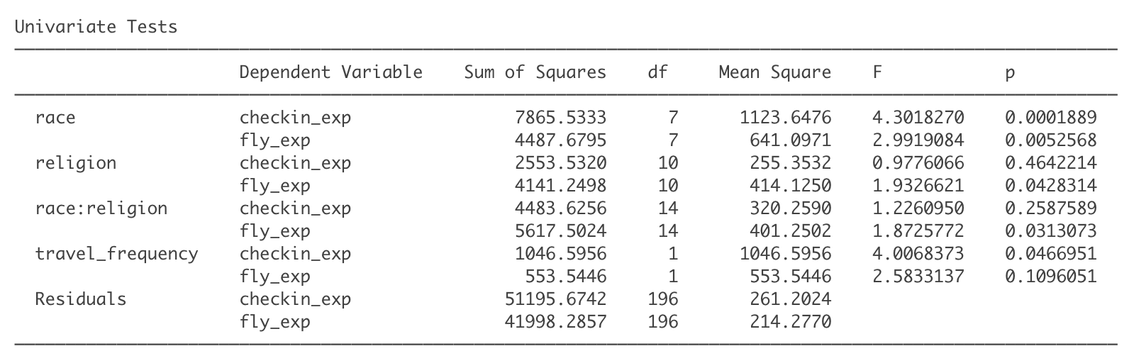

**Multivariate (MANOVA)**

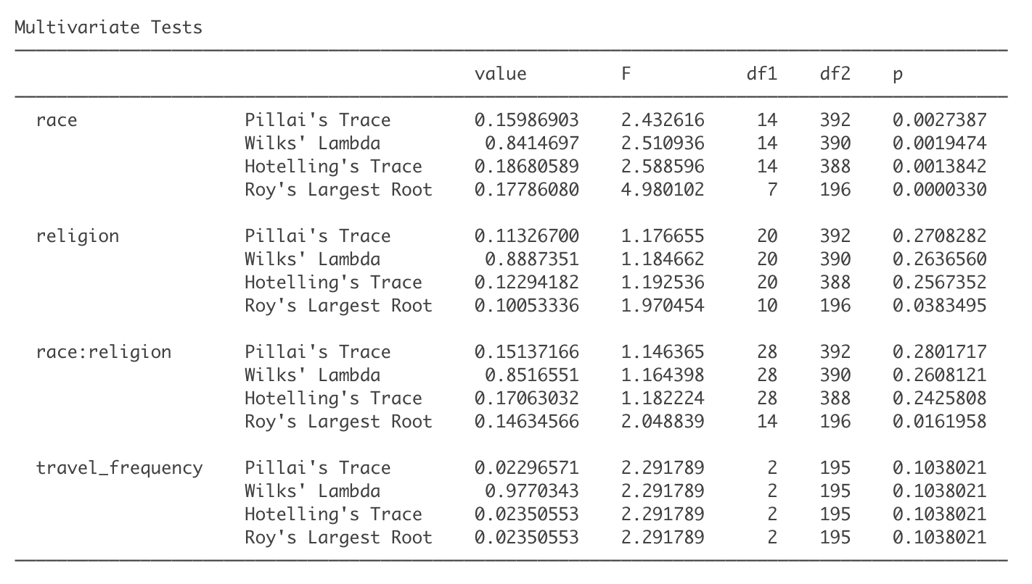

In ANCOVA settings, travel frequency has a significant univariate effect on check in experience, but not in flight experience rate. Next, in the multivariate way (MANCOVA), there’s no proof or evidence to support that the frequency of traveling has a multivariate effect on combination of dependent variables.

1. **ASSUMPTION TEST**

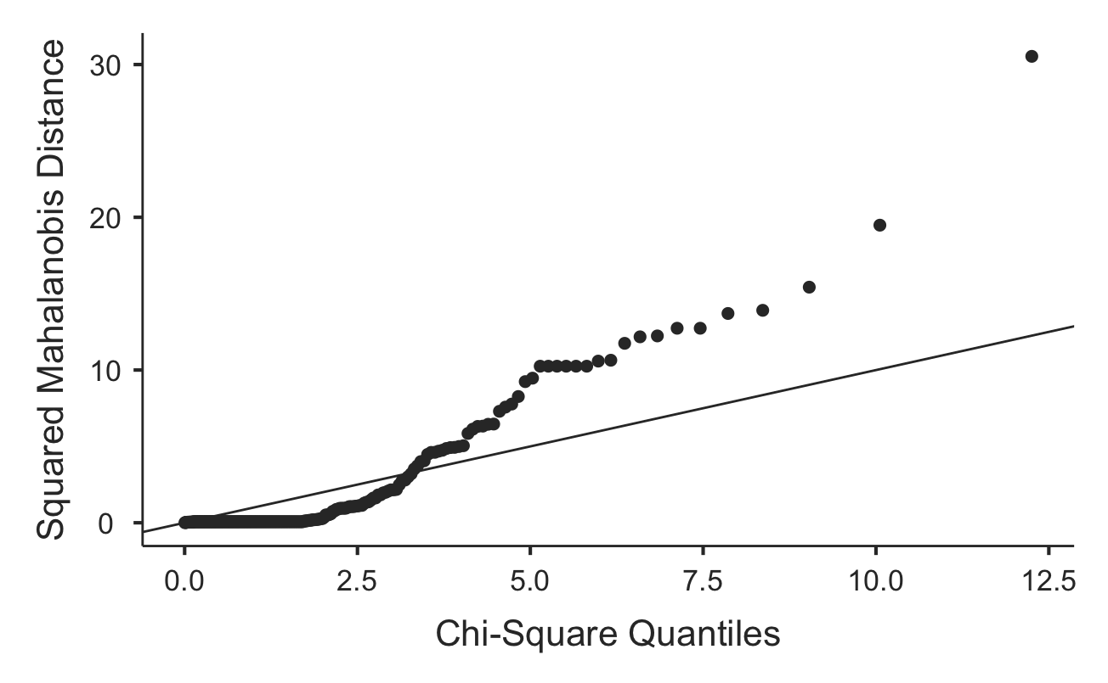

The resulting plot looks good – no evidence of serious departure from multivariate normality of the residuals.

1. **MRPP**

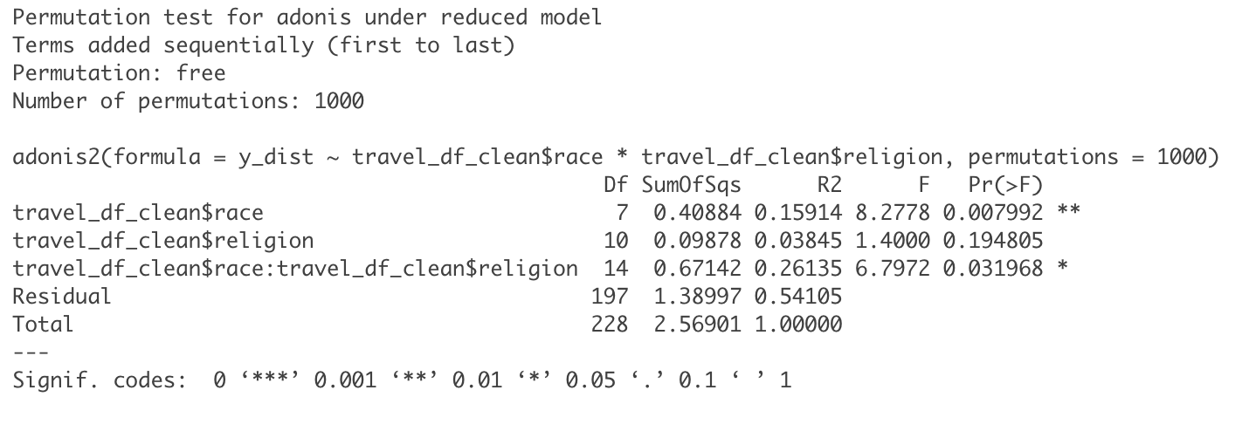

Since the assumptions of MANOVA are quite extensive, which means data is supposed to all come from multivariate normal distributions with equal covariance matrices. We can use another approach via Multi-response Permutation Procedures (MRPP). As per our findings, in the MRPP model which used 1,000 numbers of permutations, race still has a significant effect on the combination of dependent variables. Next, even though religion has no different effect on dependent variables, we can see the significant effect between race and religion.

**Summary Findings**

In this assignment, we try to perform a MANOVA model on a travel discrimination survey with dependent variables of check in and flight experience rate and the factors predictors of race and religion. We conduct analysis in univariate and multivariate settings to see if there’s any different result. In addition, we also build MANCOVA models to see if there’s any improvement in the model if we use numerical features.

By our finding, we can conclude that there's no issue with multivariate normality distribution. But again, instead of using qq-quantiles plot only, we need to conduct robust tests such as Box’s M test. We then find that in multivariate settings, both MANOVA and MANCOVA, race variables have significant effects on dependent variables. Finally, as comparison we also build MRPP model as alternative to MANOVA, we see that race and interaction shows the same significant result as MANOVA.